**AWS Cloud Practitioner Exam Q&A**

**1)** Which of the following Identity and Access Management (IAM) entities is associated with an access key ID and secret access key when using AWS command Line Interface (AWS CLI)?

A. IAM group

B. IAM user

C. IAM role

D. IAM policy

**Correct Answer: B**

**Explanation:**

Access keys are long-term credentials for an IAM user or the AWS account root user. You can use access keys to sign programmatic requests to the AWS CLI or AWS API (directly or using the AWS SDK). For more information, see Signing AWS API Requests in the Amazon Web Services General Reference.

**IAM Groups don’t login with credentials. Users are associated with groups.**

**Users are assigned to roles temporarily or more long term**

**Policy is what allows or denies you access to services and/or resources.**

**User can login with ID and credentials or use credentials and token with SDK.**

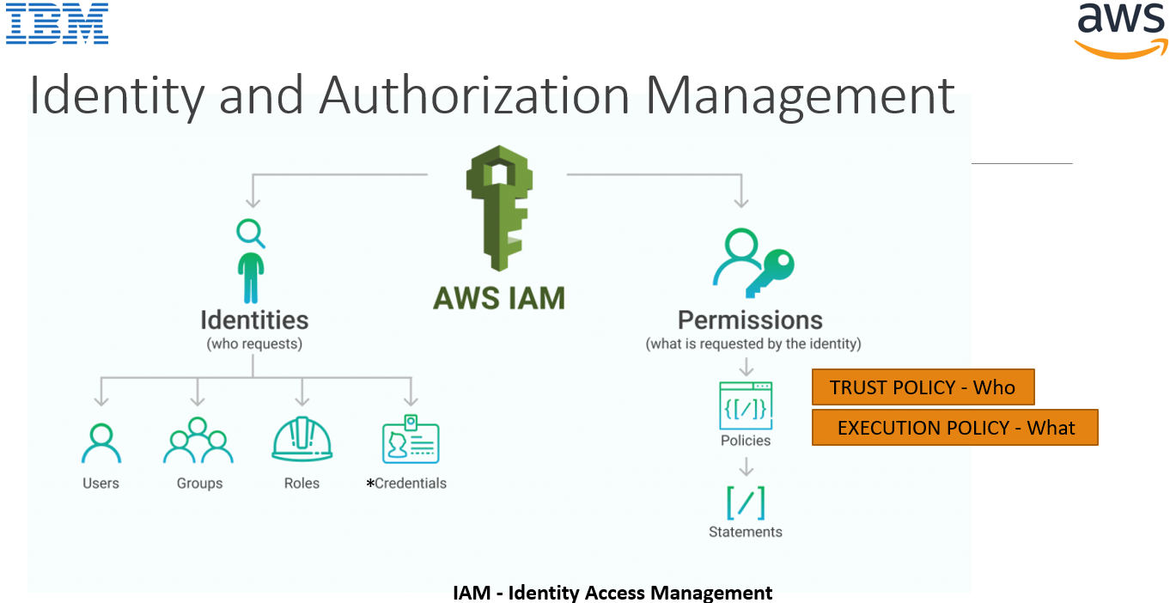

**2)** Which of the following security-related services does AWS offer? (Select TWO.)

A. Multi-factor authentication physical tokens

B. AWS Trusted Advisor security checks

C. Data encryption

D. Automated penetration testing

E. Amazon S3 copyrighted content detection

**Explanation:**

**Correct Answer: BC**

**MFA does not offer PHYSICAL tokens, but does help generate security tokens.**

**AWS Trusted Advisor Security checks all kinds of things, for security and expense, but it is more generally known as a cost savings tool.**

**Penetration testing is not correct, because it can be done by customers on their own resources.**

**There is no S3 copyrighted content detection.**

**There are not tokens associated with MFA, security tokens are assigned AFTER MFA**

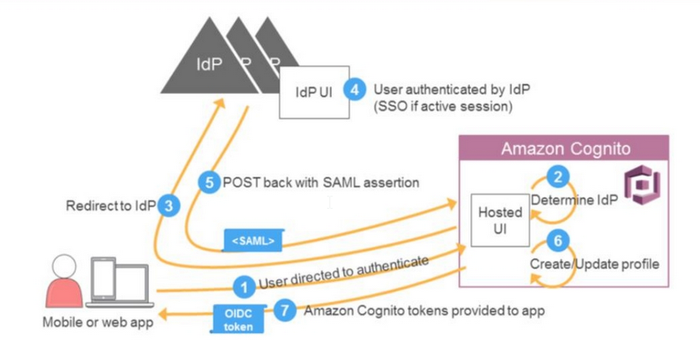

**3) Which AWS managed service is used to host databases?**

A. AWS Batch

B. AWS Artifact

C. AWS Data Pipeline

D. Amazon RDS

**Explanation:**

**AWS Batch** is tool for setting up Batch Programs and chron jobs in AWS.

**FAQ:** AWS Batch is a set of batch management capabilities that enables developers, scientists, and engineers to easily and efficiently run hundreds of thousands of batch computing jobs on AWS. AWS Batch dynamically provisions the optimal quantity and type of compute resources (e.g., CPU or memory optimized instances) based on the volume and specific resource requirements of the batch jobs submitted. With AWS Batch, there is no need to install and manage batch computing software or server clusters, allowing you to instead focus on analyzing results and solving problems. AWS Batch plans, schedules, and executes your batch computing workloads using [Amazon EC2](https://aws.amazon.com/ec2/) and [Spot Instances](https://aws.amazon.com/ec2/spot/).

**AWS Artifact** is your go-to, central resource for compliance-related information that matters to you. It provides on-demand access to AWS's security and compliance reports and select online agreements. The AWS SOC 2 report is particularly helpful for completing questionnaires because it provides a comprehensive description of the implementation and operating effectiveness of AWS security controls.

Another useful document is the Executive Briefing within the AWS FedRAMP Partner Package.

Reference: https://aws.amazon.com/compliance/faq/

**Service manages and automates application deployments on AWS? (Choose two.)**

AWS CodeCommit

AWS Data Pipeline

https://aws.amazon.com/getting-started/tutorials/continuous-deployment-pipeline/

**AWS Data Pipeline** is a web service that makes it easy to schedule regular data movement and data processing activities in the AWS cloud. AWS Data Pipeline integrates with on-premise and cloud-based storage systems to allow developers to use their data when they need it, where they want it, and in the required format. AWS Data Pipeline allows you to quickly define a dependent chain of data sources, destinations, and predefined or custom data processing activities called a pipeline. Based on a schedule you define, your pipeline regularly performs processing activities such as distributed data copy, SQL transforms, MapReduce applications, or custom scripts against destinations such as Amazon S3, Amazon RDS, or Amazon DynamoDB. By executing the scheduling, retry, and failure logic for these workflows as a highly scalable and fully managed service, Data Pipeline ensures that your pipelines are robust and highly available.

[**https://aws.amazon.com/datapipeline/faqs/**](https://aws.amazon.com/datapipeline/faqs/)

**Correct Answer: D Amazon Relational Database Service (Amazon RDS)** makes it easy to set up, operate, and scale a relational database in the cloud. It provides cost-efficient and resizable capacity while automating time- consuming administration tasks such as hardware provisioning, database setup, patching and backups. It frees you to focus on your applications so you can give them the fast performance, high availability, security and compatibility they need.

Reference: <https://aws.amazon.com/rds/?c=db&sec=srv>

**4)** Which AWS service enables users to deploy infrastructure as code by automating the process of provisioning resources?

A. Amazon GameLift

B. AWS CloudFormation

C. AWS Data Pipeline

D. AWS Glue

**Explanation:**

**Correct Answer: B**

**A. Amazon GameLift** is a managed service for deploying, operating, and scaling dedicated game servers for session-based multiplayer games. You can deploy your first game server in the cloud in just minutes, saving up to thousands of engineering hours in upfront software development and lowering the technical risks that often cause developers to cut multiplayer features from their designs. Built on AWS’s proven computing environment, Amazon GameLift lets you scale high-performance game servers up and down to meet player demand. You pay only for the capacity you use, so you can get started whether you’re working on a new game idea or running a game with millions of players.

**AWS CloudFormation** is a service that gives developers and businesses an easy way to create a collection of related AWS and third party resources and provision them in an orderly and predictable fashion. It’s a tool for deploying environments and services in AWS.

**AWS CloudFormation** provides a common language for you to model and provision AWS and third-party application resources in your cloud environment. AWS CloudFormation allows you to use programming languages or a simple text file to model and provision, in an automated and secure manner, all the resources needed for your applications across all regions and accounts. This gives you a single source of truth for your AWS and third-party resources.

Reference: https://aws.amazon.com/cloudformation/

**AWS Data Pipeline** - Question 3 answer for AWS Data Pipeline

**AWS Glue** is a fully-managed, pay-as-you-go, extract, transform, and load (ETL) service that automates the time-consuming steps of data preparation for analytics. AWS Glue automatically discovers and profiles your data via the Glue Data Catalog, recommends and generates ETL code to transform your source data into target schemas, and runs the ETL jobs on a fully managed, scale-out Apache Spark environment to load your data into its destination. It also allows you to setup, orchestrate, and monitor complex data flows. Glue is used for Big Data You have to learn a lot more about Big Data to understand Glue thoroughly

**5)** Which AWS services provide a way to extend an on-premises architecture to the AWS Cloud? (Choose two.)

A. Amazon EBS

B. AWS Direct Connect

C. Amazon CloudFront

D. AWS Storage Gateway

E. Amazon Connect

**Explanation:**

**Correct Answer: BD**

https://aws.amazon.com/hybrid/

**A)Amazon EBS (Elastic Block Store) is a Cloud technology and cannot be extended.**

**The only thing that can be extended to the premise is an instance store.**

**B)AWS Direct Connect**

**AWS Direct Connect (DX) is a cloud service solution that makes it easy to establish a dedicated network connection from your premises to AWS. Using AWS Direct Connect, you can establish private connectivity between AWS and your datacenter, office, or colocation environment, which in many cases can reduce your network costs, increase bandwidth throughput, and provide a more consistent network experience than Internet-based connections.**

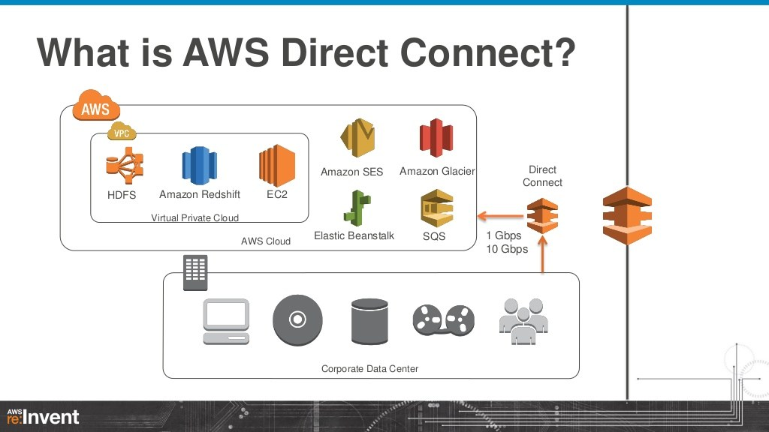

**C)Amazon CloudFront (Content Delivery Network service) Big Storage on**

Amazon CloudFront is a web service that gives businesses and web application developers an easy and cost effective way to distribute content with low latency and high data transfer speeds. Like other AWS services, Amazon CloudFront is a self-service, pay-per-use offering, requiring no long term commitments or minimum fees. With CloudFront, your files are delivered to end-users using a global network of edge locations. Amazon CloudFront provides a simple API that lets you:

* Distribute content with low latency and high data transfer rates by serving requests using a network of edge locations around the world.

**D)Amazon Connect – an AWS Call center product for you to use for your call center.**

**Amazon Connect is a SaaS application that can be used as a Call Center for your team managing inbound calls, and performing message gateway functions(chat to email, voice to text etc..)**

**\*\*\*https://docs.aws.amazon.com/index.html6)** Which AWS service should be used for long-term, low-cost storage of data backups?

A. Amazon RDS

B. Amazon Glacier

C. AWS Snowball

D. AWS EBS

**Explanation:**

**Correct Answer: B**

Amazon S3 Glacier is a secure, durable, and low-cost storage class of S3 for data archiving and long-term backup. Customers can store large or small amounts of data for as little as $0.004 per gigabyte per month. The S3 Glacier storage class is ideal for archives where data is regularly retrieved and some of the data may be needed in minutes. Amazon RDS is a relational database service that hosts databases. It helps you create and manage databases. Amazon Snowball is a petabyte-scale data transfer service that provides cost efficient data transfer to AWS from tamper proof physical devices. Similarly, Elastic block storage offers persistent block storage volumes for EC2 instances.

Reference: https://aws.amazon.com/backup-restore/services/

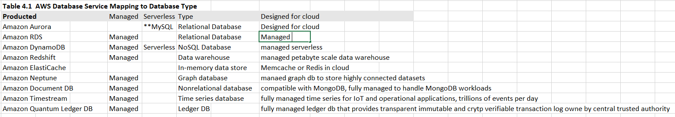

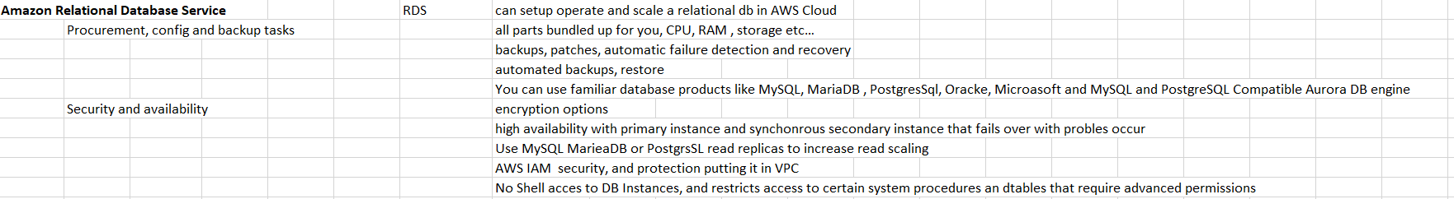

Amazon RDS provides high availability and failover support for DB instances using Multi-AZ deployments. Amazon RDS uses several different technologies to provide failover support. Multi-AZ deployments for Oracle, PostgreSQL, MySQL, and MariaDB DB instances use Amazon's failover technology. SQL Server DB instances use SQL Server Database Mirroring (DBM).

Reference: https://docs.aws.amazon.com/AmazonRDS/latest/UserGuide/Concepts.MultiAZ.html

A company wants to migrate a MySQL database to AWS but does not have the budget for Database Administrators to handle routine tasks including provisioning, patching, and performing backups. Which AWS service will support this use case?

Amazon RDS

Amazon RDS makes it easy to set up, operate, and scale a relational database in the cloud. It provides cost-efficient and resizable capacity while automating time-consuming administration tasks, such as hardware provisioning, database setup, patching, and backups. It frees you to focus on your applications, so you can give them the fast performance, high availability, security, and compatibility that they need.

**Which AWS managed service is used to host databases?** Amazon Relational Database Service (Amazon RDS) makes it easy to set up, operate, and scale a relational database in the cloud. It provides cost-efficient and resizable capacity while automating time- consuming administration tasks such as hardware provisioning, database setup, patching and backups. It frees you to focus on your applications so you can give them the fast performance, high availability, security and compatibility they need.

Reference: https://aws.amazon.com/rds/?c=db&sec=srv

Amazon RDS is a relational database service that hosts databases. It helps you create and manage databases.

Amazon Relational Database Service (Amazon RDS) offers which of the following benefits over traditional database management?

A. AWS manages the data stored in Amazon RDS tables. NO

B. AWS manages the maintenance of the operating system. YES

C. AWS automatically scales up instance types on demand. NO

D. AWS manages the database type. NO

**Correct Answer: B**

**Which AWS services can host a Microsoft SQL Server database? (Select TWO.)**

Amazon EC2

Amazon Relational Database Service (Amazon RDS)

https://aws.amazon.com/sql/

What is one of the advantages of the Amazon Relational Database Service (Amazon RDS)?

It simplifies relational database administration tasks. In the main RDS page though, Lower administrative burden is listed as part of the benefits.

https://aws.amazon.com/rds/

What is the benefit of using AWS managed services, such as Amazon ElastiCache and Amazon Relational Database Service (Amazon RDS)? They do not require the customer to optimize instance type or size selections.

https://aws.amazon.com/rds/instance-types/

Amazon RDS provides a selection of instance types optimized to fit different relational database use cases. Instance types comprise varying combinations of CPU, memory, storage, and networking capacity and give you the flexibility to choose the appropriate mix of resources for your database. Each instance type includes server instance sizes, allowing you to scale your database to the requirements of your target workload.

What feature of Amazon RDS helps to create **globally** redundant databases?

Cross-Region read replicas

https://docs.amazonaws.cn/en_us/AmazonRDS/latest/UserGuide/rds-ug.pdf

Which architectural principle is used when deploying an Amazon Relational Database Service (Amazon RDS) instance in Multiple Availability Zone mode?

Design for failure.

Amazon RDS Multi-AZ deployments provide enhanced availability and durability for Database (DB) Instances, making them a natural fit for production database workloads. When you provision a Multi-AZ DB Instance, Amazon RDS automatically creates a primary DB Instance and synchronously replicates the data to a standby instance in a different Availability Zone (AZ). Each AZ runs on its own physically distinct, independent infrastructure, and is engineered to be highly reliable. In case of an infrastructure failure, Amazon RDS performs an automatic failover to the standby (or to a read replica in the case of Amazon Aurora), so that you can resume database operations as soon as the failover is complete. Since the endpoint for your DB Instance remains the same after a failover, your application can resume database operation without the need for manual administrative intervention.

Reference: https://aws.amazon.com/rds/details/multi-az/

A company wants to migrate a MySQL database to AWS but does not have the budget for Database Administrators to handle routine tasks including provisioning, patching, and performing backups. Which AWS service will support this use case?

Amazon RDS makes it easy to set up, operate, and scale a relational database in the cloud. It provides cost-efficient and resizable capacity while automating time-consuming administration tasks, such as hardware provisioning, database setup, patching, and backups. It frees you to focus on your applications, so you can give them the fast performance, high availability, security, and compatibility that they need.

**Amazon Glacier:**

Which AWS service should be used for long-term, low-cost storage of data backups?

Amazon S3 Glacier is a secure, durable, and low-cost storage class of S3 for data archiving and long-term backup. Customers can store large or small amounts of data for as little as $0.004 per gigabyte per month. The S3 Glacier storage class is ideal for archives where data is regularly retrieved and some of the data may be needed in minutes. Amazon RDS is a relational database service that hosts databases. It helps you create and manage databases. Amazon Snowball is a petabyte-scale data transfer service that provides cost efficient data transfer to AWS from tamper proof physical devices. Similarly, Elastic block storage offers persistent block storage volumes for EC2 instances.

Reference: https://aws.amazon.com/backup-restore/services/

A Cloud Practitioner needs to store data for 7 years to meet regulatory requirements. Which AWS service will meet this requirement at the LOWEST cost?

S3 Glacier Deep Archive is Amazon S3's lowest-cost storage class and supports long-term retention and digital preservation for data that may be accessed once or twice in a year. It is designed for customers -- particularly those in highly-regulated industries, such as the Financial Services, Healthcare, and Public Sectors --that retain data sets for 7-10 years or longer to meet regulatory compliance requirements. S3 Glacier Deep Archive can also be used for backup and disaster recovery use cases, and is a cost-effective and easy-to-manage alternative to magnetic tape systems, whether they are on-premises libraries or off- premises services.

**AWS Snowball:**

Amazon Snowball is a petabyte-scale data transfer service that provides cost efficient data transfer to AWS from tamper proof physical devices. Similarly, Elastic block storage offers persistent block storage volumes for EC2 instances.

Reference: https://aws.amazon.com/backup-restore/services/

Which AWS services can be used to move data from on-premises data centers to AWS?

AWS Snowball

AWS Database Migration Service (AWS DMS)

**Other Cloud Data Migration Services:**

**AWS Direct Connect (DX)**

**AWS Snowball**

**AWS Snowball Edge**

**AWS Snowmobile**

**AWS Import/Export Disk**

**AWS Storage Gateway**

**Amazon Kinesis Data Firehose**

**Amazon S3 Transfer Acceleration**

**Virtual private network connections**

**Snowball Family:**

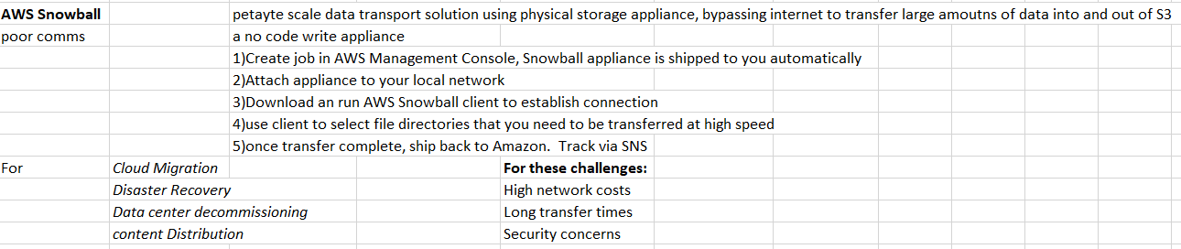

**Snowcone- portable small device for capturing IoT data in the field and shipping it to AWS to upload or put on network to do the same**

**Snowball Edge – mailed to customer device with slow network connections to load**

**SnowMobile - exabyte scale data transfer service used to move extremely large amounts of data from on prem to AWS**

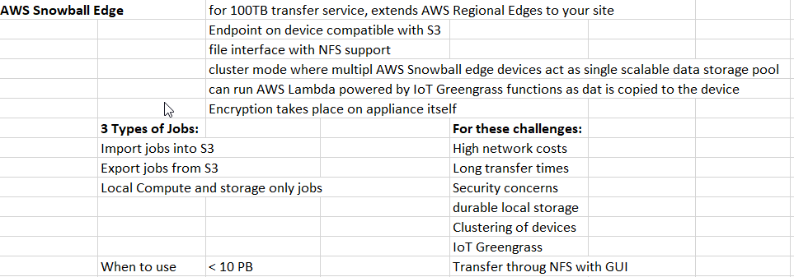

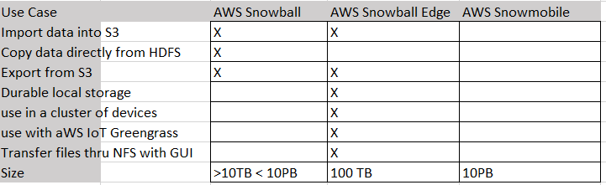

**AWS EBS: Elastic Block Storage – a block of storage (a HDD) that you can attach/detach from EC2.**

**7) \*\*\*\***Which task is AWS responsible for in the shared responsibility model for security and compliance?

A. Granting access to individuals and services

B. Encrypting data in transit

C. Updating Amazon EC2 host firmware

D. Updating operating systems

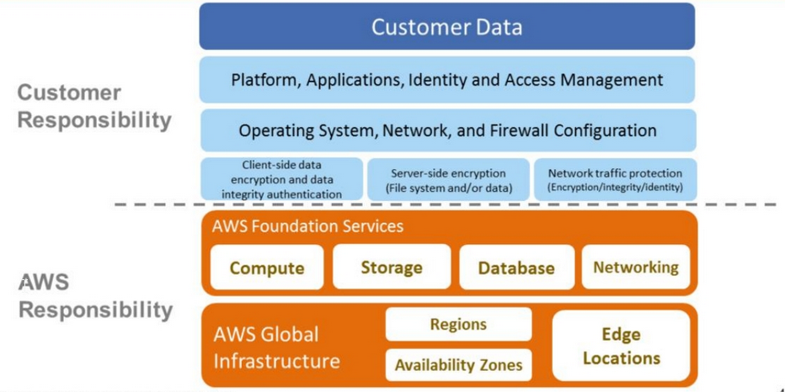

Customer responsible for items “IN” the cloud

AWS responsible for items “ON” the cloud

**Explanation:**

**Correct Answer: B**

AWS Compliance enables customers to establish and operate in an AWS security control environment. The shared responsibility model is part of AWS Compliance program:

✓ The Security of the cloud is managed by Amazon AWS provider

✓ The customer is responsible for their information and data, their secure transmission, integrity, and encryption

✓ Also, the customer is responsible for managing, support, patching and control of the guest operating system and AWS services provided like EC2

✓ AWS customers retain control and ownership of their data

✓ The AWS network provides significant protection against traditional network security issues and the customer can implement further protection

Reference: https://www.whizlabs.com/blog/aws-security-shared-responsibility/

Which of the following is a component of the shared responsibility model managed entirely by AWS?

Under the AWS shared responsibility model, which of the following activities are the customer's responsibility?

Under the shared responsibility model, which of the following is the customer responsible for?

Under the shared responsibility model, which of the following is a shared control between a customer and AWS?

Under the shared responsibility model; which of the following areas are the customer's responsibility? (Choose two.)

Under the shared responsibility model, which of the following tasks are the responsibility of the AWS customer? (Select TWO.)

Under the shared responsibility model, which of the following is a shared control between a customer and AWS?

According to the AWS shared responsibility model, what is the sole responsibility of AWS?

https://aws.amazon.com/compliance/shared-responsibility-model/

As part of the AWS shared responsibility model, which of the following operational controls do users fully inherit from AWS?

Under the shared responsibility model, which of the following tasks are the responsibility of the customer? (Choose two.)

What is the AWS customer responsible for according to the AWS shared responsibility model?

Under the AWS shared responsibility model, customer responsibilities include which one of the following?

Which of the following is the customer's responsibility under the AWS shared responsibility model?

Under the AWS shared responsibility model, customers are responsible for which aspects of security in the cloud? (Choose two.)

**What is a responsibility of AWS in the shared responsibility model?**

According to the AWS shared responsibility model, who is responsible for configuration management?

According to the AWS shared responsibility model, what is AWS responsible for?

Under the AWS shared responsibility model, AWS is responsible for which security-related task?

Under the AWS shared responsibility model, which of the following is an example of security in the AWS Cloud?

Within the AWS shared responsibility model, who is responsible for security and compliance?

Which activity is a customer responsibility in the AWS Cloud according to the AWS shared responsibility model?

What is one of the customer's responsibilities according to the AWS shared responsibility model?

Under the AWS shared responsibility model, the customer manages which of the following? (Choose two.)

Which of the following is AWS's responsibility under the AWS shared responsibility model?

**8)** Where should a company go to search software listings from independent software vendors to find, test, buy and deploy software that runs on AWS?

A. AWS Marketplace

B. Amazon Lumberyard

C. AWS Artifact

D. Amazon CloudSearch

**Correct Answer: A**

**Explanation:**

AWS Marketplace is a digital catalogue with thousands of software listings from independent software vendors that make it easy to find, test, buy, and deploy software that runs on AWS.

Reference: <https://aws.amazon.com>

Amazon Lumberyard is a free high-performance 3D engine with a professional suite of tools, editors, and libraries that enable you to create captivating real-time graphics, immersive experiences, awe-inspiring virtual worlds, and dynamic visualizations. Lumberyard brings the capabilities of Amazon Web Services and the community of Twitch to connect your ideas to players, customers, and viewers around the world.

AWS Artifact (already covered)

Amazon CloudSearch is a managed service in the AWS Cloud that makes it simple and cost-effective to set up, manage, and scale a search solution for your website or application. Amazon CloudSearch supports 34 languages and popular search features such as highlighting, autocomplete, and geospatial search.

**9)** Distributing workloads across multiple Availability Zones supports which cloud architecture design principle?

A. Implement automation.

B. Design for agility.

C. Design for failure.

D. Implement elasticity.

**Correct Answer: C**

**See my Well Architected Shortened Document**

**10) Which of the following is a benefit of using the AWS Cloud?**

A. Permissive security removes the administrative burden.

B. Ability to focus on revenue-generating activities.

C. Control over cloud network hardware.

D. Choice of specific cloud hardware vendors.

**Correct Answer: B**

**Permissive security – when you assign permissions**

**Explanation:**

Developer and IT staff productivity accounted for nearly 30% of overall financial benefits. The remaining benefits were driven by the flexibility and agility of Amazon cloud infrastructure services, which make it easier to trial new business models, support revenue-generating applications, and provide more reliable services to end users.

Reference: https://media.amazonwebservices.com/

**11)** When performing a cost analysis that supports physical isolation of a customer workload, which compute hosting model should be accounted for in the Total Cost of Ownership (TCO)?

A. Dedicated Hosts

B. Reserved Instances

C. On-Demand Instances

D. No Upfront Reserved Instances

**Correct Answer: A**

**Explanation:**

Use Dedicated Hosts to launch Amazon EC2 instances on physical servers that are dedicated for your use. Dedicated Hosts give you additional visibility and control over how instances are placed on a physical server, and you can reliably use the same physical server over time. As a result, Dedicated Hosts enable you to use your existing server-bound software licenses like Windows Server and address corporate compliance and regulatory requirements.

Also TCO typically refers to the TCO calculator <https://aws.amazon.com/tco-calculator/>

When comparing AWS Cloud with on-premises Total Cost of Ownership, which expenses must be considered? (Choose two.)

A. Software development NO

B. Project management NO

C. Storage hardware YES

D. Physical servers YES

E. Antivirus software license NO

**Correct Answer: CD**

**Explanation:**

Intended to give you a feasibility of moving from prem to cloud.

https://aws.amazon.com/blogs/aws/the-new-aws-tco-calculator/

**AWS Total Cost of Ownership (TCO)** – tools to isolate cost of putting customer workload

currently not on AWS to being on AWS (on-Prem or hosted elsewhere)

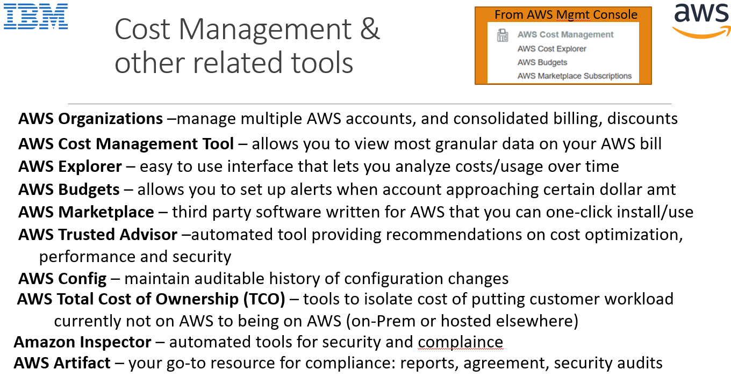

**12)** Which AWS service provides the ability to manage infrastructure as code?

A. AWS CodePipeline

B. AWS CodeDeploy

C. AWS Direct Connect

D. AWS CloudFormation

**Explanation:**

**Correct Answer: D**

AWS CloudFormation provides a common language for you to describe and provision all the infrastructure resources in your cloud environment. CloudFormation allows you to use a simple text file to model and provision, in an automated and secure manner, all the resources needed for your applications across all regions and accounts. This file serves as the single source of truth for your cloud environment.

Reference: https://aws.amazon.com/cloudformation/

**Which services manage and automate application deployments on AWS? (Choose two.)**

AWS CodeCommit

AWS Data Pipeline

A company wants to migrate its applications to a VPC on AWS. These applications will need to access on- premises resources. What combination of actions will enable the company to accomplish this goal?

B. Build a VPN connection between on-premises device and a virtual private gateway in new VPC.

D. Connect the company's on-premises data center to AWS using AWS Direct Connect.

A company requires a dedicated network connection between its on-premises servers and the AWS Cloud. Which AWS service should be used? AWS Direct Connect

You can use AWS Direct Connect to establish a private virtual interface from your on-premise network directly to your Amazon VPC, providing you with a private, high bandwidth network connection between your network and your VPC. With multiple virtual interfaces, you can even establish private connectivity to multiple VPCs while maintaining network isolation.

Reference: https://aws.amazon.com/directconnect/

**AWS CloudFormation** is a service that gives developers and businesses an easy way to create a collection of related AWS and third party resources and provision them in an orderly and predictable fashion. It’s a tool for deploying environments and services in AWS.

**13)** If a customer needs to audit the change management of AWS resources, which of the following AWS services should the customer use?

A. AWS Config

B. AWS Trusted Advisor

C. Amazon CloudWatch

D. Amazon Inspector

**Correct Answer: A**



**Explanation:**

AWS Config is a service that enables you to assess, audit, and evaluate the configurations of your AWS resources. Config continuously monitors and records your AWS resource configurations and allows you to automate the evaluation of recorded configurations against desired configurations. With Config, you can review changes in configurations and relationships between AWS resources, dive into detailed resource configuration histories, and determine your overall compliance against the configurations specified in your internal guidelines. This enables you to simplify compliance auditing, security analysis, change management, and operational troubleshooting.

Reference: https://aws.amazon.com/config/

**14) What is Amazon CloudWatch?**

A. A code repository with customizable build and team commit features.

B. A metrics repository with customizable notification thresholds and channels.

C. A security configuration repository with threat analytics.

D. A rule repository of a web application firewall with automated vulnerability prevention features.

**Explanation:**

**Correct Answer: B**

Amazon CloudWatch is basically a metrics repository. An AWS service -- such as Amazon EC2 -- puts metrics into the repository, and you retrieve statistics based on those metrics. If you put your own custom metrics into the repository, you can retrieve statistics on these metrics as well.

See CloudWatch Section at end.

Reference: https://docs.aws.amazon.com/AmazonCloudWatch/latest/monitoring/cloudwatch_architecture.html

**15)** What AWS service would be used to centrally manage AWS access policies across multiple accounts?

A. AWS Service Catalogue

B. AWS Config

C. AWS Trusted Advisor

D. AWS Organizations

**Correct Answer: D**

**Explanation:**

AWS Organizations helps you centrally govern your environment as you grow and scale your workloads on AWS. Whether you are a growing start-up or a large enterprise, Organizations helps you to centrally manage billing; control access, compliance, and security; and share resources across your AWS accounts.

Reference: https://aws.amazon.com/organizations/ 6 @Owned by Kishore

If each department within a company has its own AWS account, what is one way to enable consolidated billing?

Create an AWS Organization from the payer account and invite the other accounts to join.

Which is the minimum AWS Support plan that includes Infrastructure Event Management without additional costs?

Business

https://aws.amazon.com/premiumsupport/plans/

What AWS team assists customers with accelerating cloud adoption through paid engagements in any of several specialty practice areas?

AWS Professional Services

https://aws.amazon.com/professional-services/

**16) What is AWS Trusted Advisor?**

A. It is an AWS staff member who provides recommendations and best practices on how to use AWS.

B. It is a network of AWS partners who provide recommendations and best practices on how to use AWS.

C. It is an online tool with a set of automated checks that provides recommendations on cost optimization, performance, and security.

D. It is another name for AWS Technical Account Managers who provide recommendations on cost optimization, performance, and security.

**Correct Answer: C**

**Explanation:**

AWS Trusted Advisor is an online tool that provides you real time guidance to help you provision your resources following AWS best practices.

Whether establishing new workflows, developing applications, or as part of ongoing improvement, take advantage of the recommendations provided by Trusted Advisor on a regular basis to help keep your solutions provisioned optimally.

Reference: https://aws.amazon.com/premiumsupport/technology/trusted-advisor/

**17)** Which service allows a company with multiple AWS accounts to combine its usage to obtain volume discounts?

A. AWS Server Migration Service

B. AWS Organizations

C. AWS Budgets

D. AWS Trusted Advisor

**Correct Answer: B**

**Explanation:**

AWS Organizations is an account management service that enables you to consolidate multiple AWS accounts into an organization that you create and centrally manage. AWS Organizations includes account management and consolidated billing capabilities that enable you to better meet the budgetary, security, and compliance needs of your business. As an administrator of an organization, you can create accounts in your organization and invite existing accounts to join the organization.

Use the consolidated billing feature in AWS Organizations to consolidate billing and payment for multiple AWS accounts or multiple Amazon Internet Services Pvt. Ltd (AISPL) accounts. Every organization in AWS Organizations has a master account that pays the charges of all the member accounts. Consolidated billing has the following benefits:

** Easy tracking You can track the charges across multiple accounts and download the combined cost and usage data.**

** Combined usage You can combine the usage across all accounts in the organization to share the volume pricing discounts and Reserved Instance discounts.**

** This can result in a lower charge for your project, department, or company than with individual standalone accounts. For more information, see Volume Discounts.**

**https://docs.aws.amazon.com/organizations/latest/userguide/orgs_introduction.html**

**18)** Which of the following services could be used to deploy an application to servers running on-premises? (Select TWO.)

A. AWS Elastic Beanstalk

B. AWS OpsWorks

C. AWS CodeDeploy

D. AWS Batch

E. AWS X-Ray

**Correct Answer: BC**

**Explanation:**

https://docs.aws.amazon.com/codedeploy/latest/userguide/instances-on-premises.html

With **AWS Elastic Beanstalk**, you can quickly deploy and manage applications in the AWS Cloud without worrying about the infrastructure that runs those applications. AWS Elastic Beanstalk reduces management complexity without restricting choice or control. You simply upload your application, and AWS Elastic Beanstalk automatically handles the details of capacity provisioning, load balancing, scaling, and application health monitoring. Deploying Architecture, not just code.

**AWS Batch -see Question 3**

**AWS X-Ray is a debugging tracing tool used to traverse through objects.** AWS X-Ray makes it easy for developers to analyze the behavior of their distributed applications by providing request tracing, exception collection, and profiling capabilities.

**https://docs.aws.amazon.com/xray/?id=docs_gateway**

**Output from X-Ray, good for debugging sluggishness or transfers between objects.**

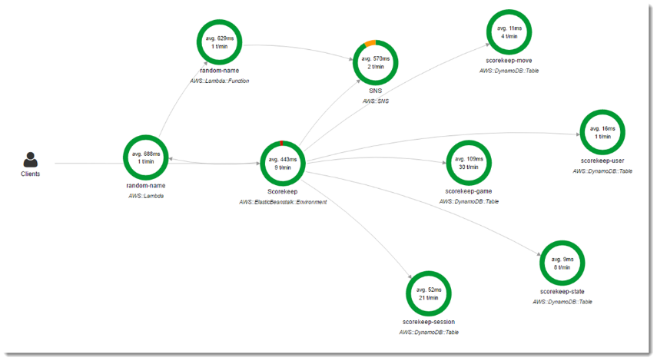

**AWS CodeDeploy** is a deployment service that enables developers to automate the deployment of applications to instances and to update the applications as required.

**AWS OpsWorks** is a configuration management service that helps you configure and operate applications in a cloud enterprise by using Puppet or Chef. AWS OpsWorks Stacks and AWS OpsWorks for Chef Automate let you use [Chef](https://www.chef.io) cookbooks and solutions for configuration management, while OpsWorks for Puppet Enterprise lets you configure a [Puppet Enterprise](https://puppet.com/products/puppet-enterprise) master server in AWS. Puppet offers a set of tools for enforcing the desired state of your infrastructure, and automating on-demand tasks.

**19)** Which Amazon EC2 pricing model adjusts based on supply and demand of EC2 instances?

A. On-Demand Instances

B. Reserved Instances

C. Spot Instances

D. Convertible Reserved Instances

**Correct Answer: C**

**Explanation:**

In the new model, the Spot prices are more predictable, updated less frequently, and are determined by supply and demand for Amazon EC2 spare capacity, not bid prices.

Reference: https://aws.amazon.com/blogs/compute/new-amazon-ec2-spot-pricing/

**Need to read up on this.**

**Spot are short term instances for on the moment needs but subject to available resources.**

**Does not bill partial as you may get interrupted.**

**If you need resources go with Reserved Instance.**

**Convertible Reserved Instances.**

**Can be used for whatever you convert them into.**

**20)** Which design principles for cloud architecture are recommended when re-architecting a large monolithic application? (Select TWO.)

A. Use manual monitoring.

B. Use fixed servers.

C. Implement loose coupling.

D. Rely on individual components.

E. Design for scalability.

**Correct Answer: CE**

**See Well Architected Document**

**Loose coupling - doesn’t depend on other things, other than it receives from or sends**

**Scalability – needs to be able to scale up or down as demand requires**

**21)** Which is the MINIMUM AWS Support plan that allows for one-hour target response time for support cases?

A. Enterprise

B. Business

C. Developer

D. Basic

**Correct Answer: B**

**Explanation:**

https://aws.amazon.com/premiumsupport/plans/

Where should users report that AWS resources are being used for malicious purposes?

AWS Abuse team

A company is migrating from on-premises data centers to the AWS Cloud and is looking for hands-on help with the project. How can the company get this support? (Choose two.)

- Contact AWS Support and open a case for assistance

- Use AWS Professional Services to provide guidance and to set up an AWS Landing Zone in the company's AWS account

**How does the AWS Enterprise Support Concierge team help users?**

Answering billing and account inquires

https://aws.amazon.com/premiumsupport/plans/enterprise/

AWS Enterprise Support users have access to which service or feature that is not available to users with other AWS Support plans? Concierge team

https://aws.amazon.com/premiumsupport/plans/

**Which AWS support plan includes a dedicated Technical Account Manager?** Enterprise

Reference: https://aws.amazon.com/premiumsupport/plans/

Which is the MINIMUM AWS Support plan that provides technical support through phone calls? Business https://aws.amazon.com/premiumsupport/plans/

Which is the MINIMUM AWS Support plan that provides designated Technical Account Managers? Enterprise

https://aws.amazon.com/premiumsupport/plans/

**What exclusive benefit is provided to users with Enterprise Support?** . Access to a Technical Account Manager

https://aws.amazon.com/premiumsupport/plans/enterprise/

**Which AWS Support plan provides a full set of AWS Trusted Advisor checks?** Enterprise and Business Support

<https://aws.amazon.com/premiumsupport/plans/>

How can an AWS user with an AWS **Basic** Support plan obtain technical assistance from AWS? AWS Trusted Advisor

<https://aws.amazon.com/premiumsupport/faqs>

A company is migrating from on-premises data centers to the AWS Cloud and is looking for hands-on help with the project. How can the company get this support? (Choose two.)

B. Contact AWS Support and open a case for assistance

C. Use AWS Professional Services to provide guidance and to set up an AWS Landing Zone in the company's AWS account

https://aws.amazon.com/solutions/aws-landing-zone/

**22)** Which of the following **inspects** AWS environments to find opportunities that can save money for users and also improve system performance?

A. AWS Cost Explorer

B. AWS Trusted Advisor

C. Consolidated billing No Consolidated Billing, only Cost Management Tools and Detailed billing

D. Detailed billing

**Correct Answer: B**



**23)** Which of the following Amazon EC2 pricing models allow customers to use existing server-bound software licenses?

A. Spot Instances

B. Reserved Instances

C. Dedicated Hosts

D. On-Demand Instances

**Correct Answer: C**

**Explanation:**

https://aws.amazon.com/ec2/pricing/

**24) Where can AWS compliance and certification reports be downloaded?**

A. AWS Artifact

B. AWS Concierge

C. AWS Certificate Manager

D. AWS Trusted Advisor

**Correct Answer: A**

**Explanation:**

Artifact is your go-to, central resource for compliance-related information that matters to you. It provides on-demand access to AWS's security and compliance reports and select online agreements. The AWS SOC 2 report is particularly helpful for completing questionnaires because it provides a comprehensive description of the implementation and operating effectiveness of AWS security controls.

Another useful document is the Executive Briefing within the AWS FedRAMP Partner Package.

Reference: https://aws.amazon.com/compliance/faq/

**25)** Which AWS service provides a customized view of the health of specific AWS services that power a customer's workloads running on AWS?

A. AWS Service Health Dashboard

B. AWS X-Ray

C. AWS Personal Health Dashboard

D. Amazon CloudWatch

**Correct Answer:** C

CloudWatch is for viewing metrics

X-Ray is for debugging

Service Health Dashboard is for System Health (AWS)

Personal Health Dashboard is for YOUR components

**AWS Trusted Advisor - considered more of a cost tool**

Take Advantage of the recommendations provided by Trusted Advisor on a regular basis

Here are some Trusted Advisor checks that help you determine how to reduce your bill.

Low utilization of Amazon EC2 instances

Idle resources, such as load balancers and Amazon RDS DB instances

Underutilized Amazon EBS volumes and Amazon Redshift Clusters

Unassociated Elastic IP Addresses

Optimization, lease expiration - Amazon Reserved Instances

Inefficiently configured Amazon Route 53 latency record sets

Use AWS Trusted Advisor to inspect your AWS infrastructure to identify overutilized or idle resources.

Know how the AWS Trusted Advisor features help in saving costs and improving the performance of your solutions.

AWS Trusted Advisor scans your AWS Environment, compares it to AWS best practices, and makes **recommendations for saving money, improving system performance, and more.**

Cost Optimzation recommendations highlight unused system performance and more.

Cost Optimization recommendations highlight unused and underutilized resources.

Performance recommendation help to improve the speed and responsiveness of your applications.

The AWS Trusted Advisor checks include recommendations regarding which of the following? (Choose two.)

A. Information on Amazon S3 bucket permissions

B. AWS service outages

C. Multi-factor authentication enabled on the AWS account root user

D. Available software patches

E. Number of users in the account

**Correct Answer: AC**

**Explanation:**

https://aws.amazon.com/premiumsupport/technology/trusted-advisor/best-practice-checklist/

**Which of the following are categories of AWS Trusted Advisor? (Select TWO.)**

A. Fault Tolerance

B. Instance Usage

C. Infrastructure

D. Performance

E. Storage Capacity

**Correct Answer: AD**

**Explanation:**

Like your customized cloud expert, AWS Trusted Advisor analyzes your AWS environment and provides best practice recommendations in five categories: cost optimization, performance, security, fault tolerance and service limits.

Reference: https://aws.amazon.com/premiumsupport/technology/trusted-advisor/

**END AWS Trusted Advisor**

START: AWS WELL ARCHITECTED SOLUTIONS

<https://aws.amazon.com/blogs/apn/the-5-pillars-of-the-aws-well-architected-framework/>

END: AWS WELL ARCHITECTED SOLUTIONS

**BEGIN AWS SERVICES**

**\*\*\*https://docs.aws.amazon.com/index.html**

**END AWS SERVICES**

**BEGIN CLOUDWATCH**

CloudWatch – aka Metrics Repository (Most AWS apps write to it by default)

CloudWatch is the service used to aggregate, analyze, and alert on metrics generated by other AWS services.

It is used to monitor the resources you create in AWS and the on-premises infrastructure.

You can use CloudWatch to store logs from your applications and trigger actions in response to events.

Know what common metrics are available for Amazon Elastic Compute Cloud (Amazon EC2) in Amazon CloudWatch

CPUUtilization

DiskReadOps

DiskReadBytes

DiskWriteBytes

NetworkIn

NetworkOut

StatusCheckFailed

Amazon EC2 does not report OS-level metrics such as memory utilization

Best case scenario, CloudWatch automatically detects unhealthy instance and alerts AWS AutoScaling to luanch and configure an identical server, notifies the adminitrator and logs the action to your change management solution.

Know what Amazon CloudWatch is and why it is used

AMAZON CLOUDWATCH a monitoring and metrics service that provides you with a fully managed sysem to collect store and analyze your metrics and logs

By using CloudWatch, you can create notifications on changes in your environment

Typical use cases:

Infrastructure monitoring and troubleshooting

Resource optimization

Application monitoring

Logging analytics

Error reporting and notification

CloudWatch enables you to collect and store monitoring and operations data from logs, metrics and events that run on AWS AND on-premises resources

Use CloudWatch to perform the following tasks:

Set alarms

Visualize logs and metrics

Automate recovery from errors

Troubleshoot issues

Discover insights that enable you to optimize your resources

How Amazon CloudWatch Works

CloudWatch acts as a metrics repository, storing metrics and logs from various sources.

These metrics come from AWS resources using built-in or custom metrics.

Figure 15.2 Pg 801

CloudWatch can process these metrics in to stats that are made available through the CloudWatch console, AWS APIs, AWS CLI and AWS SDK.

Using CloudWatch, you can display graphs, create alarms or integrate with third party solutions

**END CLOUDWATCH**